# Create a Todo App in SAP Build Apps Community Edition Part 2 – List Todos

Navigate to appgyver.com.

Click Learn more in the Looking for the Community Edition tile. Click Login/Sign up

Complete the sign up process then log in. The tiles in the image below are apps. You shouldn’t have any at this point. To create one, click CREATE NEW.

Enter a name and click CREATE.

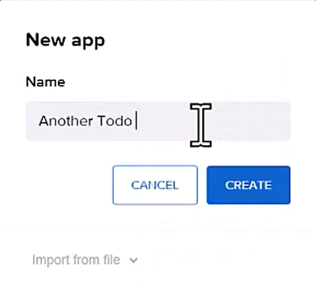

The app is created and the UI CANVAS is opened to the main page.

On the left is the toolbox which contains controls you can drag onto the canvas to create the interface. In addition to the CORE controls, you can use the Marketplace to install more controls.

On the bottom right is the TREE, which shows the interface in outline form. It’s often easier to arrange controls using the TREE.

The center of the screen is the canvas that shows what the interface will look like. On the top right is the properties pane which you use to configure controls.

Change the Page name to something like My Todos. If you selected a control and the Page properties aren’t visible, click on the whitespace on the canvas.

Select the Title control and change the Content to something like My Todos.

Delete the Text control. Save the app.

To enable our app to access the Todo backend app, we have to create a Data resource. Click Data in the top menu.

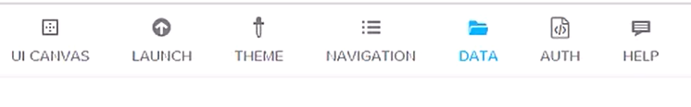

Click ADD DATA RESOURCE on the top right and select REST API direction integration.

To get the Resource URL, go back to Xano and use the Copy Endpoint icon to copy the URL.

In SAP Build Apps configure the Data resource like this (notice the Resource URL in the image won’t match yours):

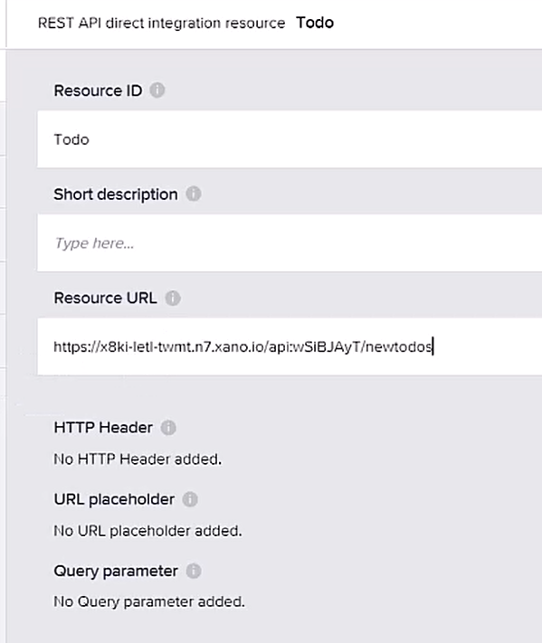

The CRUD services are listed on the left side of the screen. Click GET COLLECTION (GET).

Select the TEST tab.

Click RUN TEST.

To set the Schema for the Data resource, click SET SCHEMA FROM RESPONSE. The schema is set.

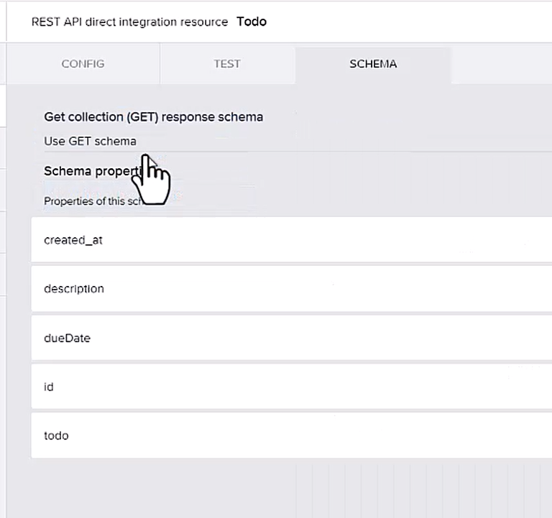

Return to the UI CANVAS.

When the service returns data, we need to have a variable where we can store the data and bind it to the interface. Click VARIABLES on the top right of the screen.

Variables that connect to a Data resource are called Data Variables. Click DATA VARIABLES in the list on the left side of the screen.

Click ADD DATA VARIABLE on the right side of the screen and select the Todo data resource.

Select the new data variable and change the Data variable name in the properties.

Note that the Data variable type is set to Collection of data records. This tells SAP Build Apps to use the get all todos service.

Click the black bar along the bottom of the screen to open the logic pane.

This shows the logic used to retrieve the data and set it into our Todos data variable. When the page is mounted (opened), the Get record collection is called to load the data. The data is then loaded into the data variable. Notice that the service is called every 5 second by default because of the Delay component.

Next, we’ll add a list to the interface that we can bind to the data variable. Click VIEW on the top right to return to the canvas.

Although we can construct a list using the CORE controls, we can install a preconstructed list from the MARKETPLACE. Click MARKETPLACE.

If you don’t see the Basic list, you can use the search field at the top of the screen to find it.

Click the Basic List, then click INSTALL.

You’ll find the Basic list control at the top of the list of controls on INSTALLED tab.

Drag onto the canvas below the Title control.

With the list selected, click Configure in the PROPERTIES.

Click on the Todo data integration tile.

Drag the todo, description and dueDate from Available fields onto the controls as shown:

The id is a bit trickier because it’s a number and the field is a text control. We have to create a formula to convert id to text. Click the lightning bolt icon at the end of the id control.

Select Utility in the list on the left.

Scroll down, select the STRING function then click Enter.

This adds the function to the formula:

Now, to replace value with the id, click Source object in the list on the left, then click source.record.id. If it doesn’t substitute the value, click Enter.

Click SAVE AND EXIT.

Save the app then lick LAUNCH TO run it.

Click OPEN APP PREVIEW PORTAL.

Then click OPEN on the app’s tile.

